

The Simple Medical Imaging Library Interface (SMILI) is a light weight, simple to use framework for medical imaging processing and visualisation.

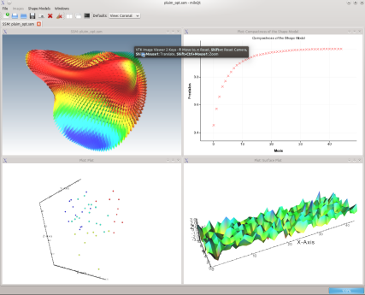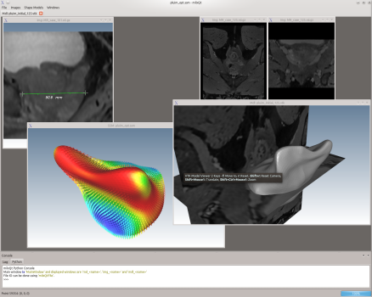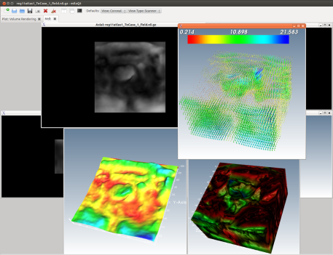

* Open, convert, visualise and process images, as well as models/surfaces, easily with an intuitive and fast user-interface or using command-line applications.
* Easily visualise and interact with images and models using drag-n-drop and the mouse.
* Modify, develop and integrate into your own workflow with SMILI’s liberal [MPL 2.0](http://www.mozilla.org/MPL/) license.
* Easily extend or create applications and plugins. The [Qt](http://qt.digia.com/) based framework and is built on-top of a light-weight wrapper of the [Insight Toolkit (ITK)](http://www.itk.org/) and the [Visualisation Toolkit (VTK)](http://www.vtk.org/); so same functionalities are available as a user-interface or as command line applications.

Features:

* View and convert 2D/3D/4D images with support for Analyze, Nifti, DICOM, TIFF and many more formats.
* Imaging features include masking, resampling, smoothing filters, edge detection filters, overlaying labels, volume rendering, surface plots, arithmetic operations and many more

